
LTSA LAB REPORT
Department of Computer Science &
Engineering

Name : Md. Jubayer Hasan
Id : 2022-2-60-042
Course : CSE430
Section : 01
Date : 23 October 2025

1.model a toggle switch (SWITCH) that alternates between on and off states.
code :
SWITCH = ( on -> off -> SWITCH ).

Output
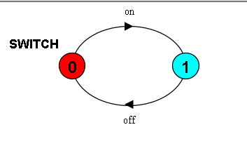
2. Develop a simple Traffic Light Controller with states Red → Green → Yellow → Red
code :
TRAFFIC = ( red -> green -> yellow -> TRAFFIC ).
output :
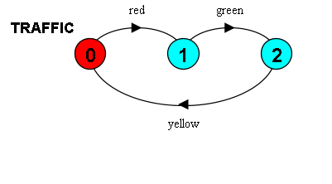
3. Extend the Drinks Machine model with a cancel option.
code :
DRINKS = ( select -> ( coffee -> serve -> DRINKS
| tea -> serve -> DRINKS
| cancel -> DRINKS ) ).
output :
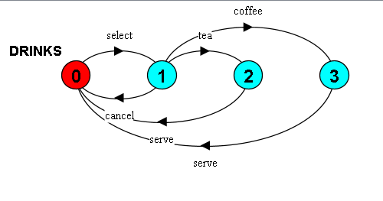

4.Simulate a Coin Toss Machine using non-deterministic choice.

Code :
COIN = ( toss -> ( heads -> COIN
| tails -> COIN ) ).
Output
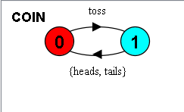
5. Create a Counter model with guard conditions to restrict underflow and overflow.
Code :
COUNT(N=3) = COUNT[0],
COUNT[i:0..N] = ( when(i<N) inc -> COUNT[i+1]
| when(i>0) dec -> COUNT[i-1]
| when(i==0) read -> COUNT[i]
| when(i==N) read -> COUNT[i] ).

Output :

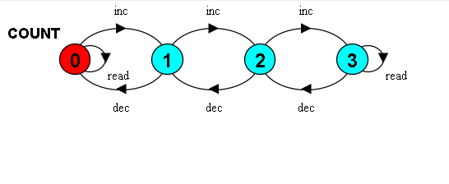
6. Build a Maker–User synchronization system using shared actions
code
MAKER = ( make -> ready -> MAKER ).
USER = ( ready -> use -> USER ).
||MAKER_USER = ( MAKER || USER ).
output
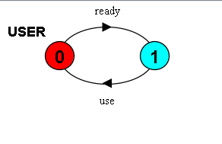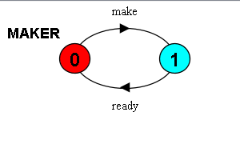
7. Implement a Client–Server model using relabelling to synchronize request and reply actions.
code :
CLIENT = ( call -> wait -> continue -> CLIENT ).
SERVER = ( request -> service -> reply -> SERVER ).
||CLIENT_SERVER = ( CLIENT || SERVER ) / { call/request, reply/wait }.
output :
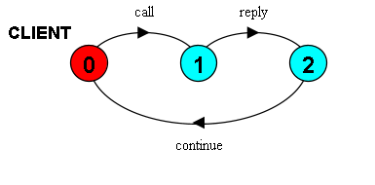
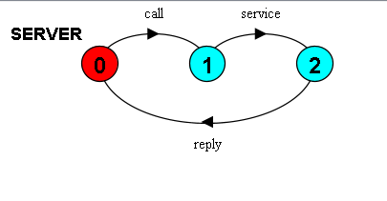

8. Construct a Shared Printer model ensuring only one user can use the printer at a time.
code :
PRINTER = ( acquire -> use -> release -> PRINTER ).

USER_A = ( printer.acquire -> do_print -> printer.release -> USER_A ).
USER_B = ( printer.acquire -> do_print -> printer.release -> USER_B ).

||SHARED_PRINTER = ( a:USER_A || b:USER_B || {a,b}::printer:PRINTER ).
output :
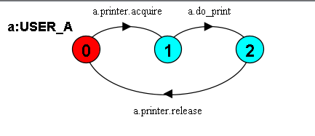
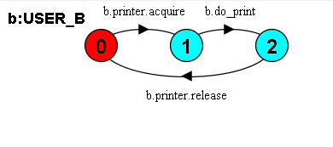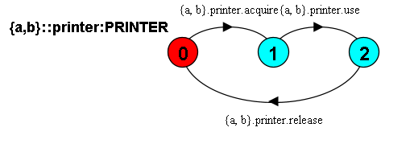

9. Analyze the ATM system model for safety: verify that cash is never dispensed without successful authorization.
code :
USER_ATM =
( insert_card -> prompt_pin -> enter_pin -> auth_req ->
( auth_ok -> select_withdraw -> amount -> take_cash -> return_card -> USER_ATM
| auth_fail -> return_card -> USER_ATM )
).

ATM =
( insert_card -> prompt_pin -> enter_pin -> auth_req ->
( auth_ok -> select_withdraw -> amount -> debit_req ->
( debit_ok -> dispense_cash -> return_card -> ATM
| debit_fail-> show_error -> return_card -> ATM )
| auth_fail -> return_card -> ATM )
).

BANK =
( auth_req -> ( auth_ok -> BANK | auth_fail -> BANK )
| debit_req -> ( debit_ok -> BANK | debit_fail -> BANK )
).

||ATM_SYSTEM = ( USER_ATM || ATM || BANK ).

PROPERTY_SAFE_DISPENSE =
( auth_ok -> AUTHORIZED
| auth_fail -> PROPERTY_SAFE_DISPENSE ).

AUTHORIZED =
( debit_ok -> CAN_DISPENSE
| debit_fail -> PROPERTY_SAFE_DISPENSE ).

CAN_DISPENSE =
( dispense_cash -> PROPERTY_SAFE_DISPENSE
| debit_fail -> PROPERTY_SAFE_DISPENSE ).

||CHECK = ( ATM_SYSTEM || PROPERTY_SAFE_DISPENSE ).
output :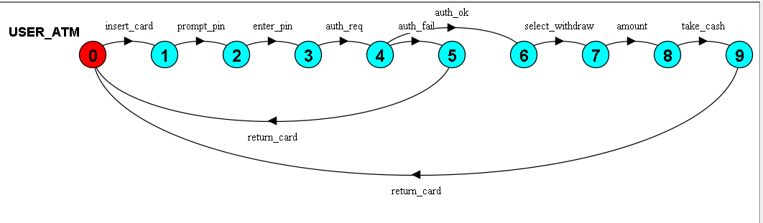
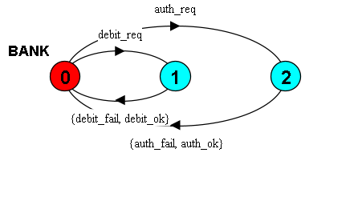
10. Add a progress property to confirm that the card is always returned after any transaction.
code :
USER =
( insert_card -> prompt_pin -> enter_pin -> auth_req ->
( auth_ok ->
select_withdraw -> amount ->
( dispense_cash -> take_cash -> return_card -> take_card -> USER
| show_error -> return_card -> get_card_back -> USER
)
| auth_fail ->
return_card -> get_card_back -> USER
)
).

ATM =
( insert_card -> prompt_pin -> enter_pin -> auth_req ->
( auth_ok ->
select_withdraw -> amount -> debit_req ->
( debit_ok -> dispense_cash -> return_card -> ATM
| debit_fail-> show_error -> return_card -> ATM
)
| auth_fail -> return_card -> ATM
)
).

BANK =
( auth_req -> (auth_ok -> BANK
| auth_fail -> BANK)
| debit_req -> (debit_ok -> BANK
| debit_fail-> BANK)
).

||ATM_SYSTEM = ( USER || ATM || BANK ).

progress CARD_RETURN = { return_card }

output :
